# Module Specification:

# CIM Level 4 Award in Customer Insights (VRQ)

Customer Insights is a 17-credit elective module which sits within the suite of

Level 4 modules.

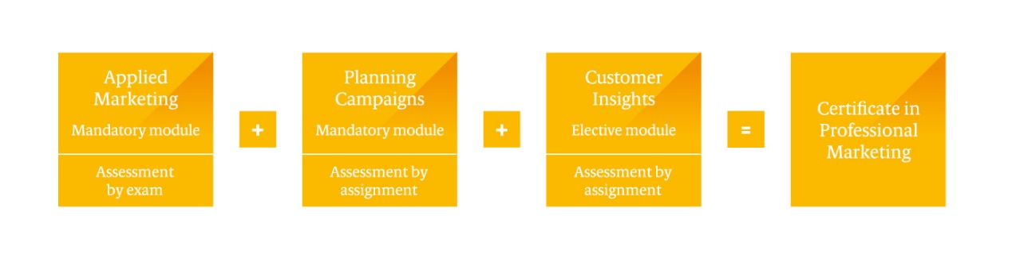

To gain the CIM Level 4 Certificate in Professional Marketing, a pass in both mandatory modules plus the elective module is required.

If studied as a standalone module, the CIM Level 4 Award in Customer Insights (VRQ) can be achieved.

## Aim of the module

Customer loyalty, the customer/user experience and customer insight are the core of achieving optimum satisfaction and retention. This module gives you an understanding of the contemporary customer’s complex needs and wants, their behaviour as consumers and how this sets their expectations. You will learn how to gain the insight required to understand those needs and map the journey to ultimately improve their experience.

## Module structure

The module comprises three units of two learning outcomes each. Each learning outcome will be covered by the related assessment criteria and will be assessed by way of assignment. The assessment will require submission of an assignment based on a theme and an organisation of choice.

The learning outcomes and assessment criteria, along with the indicative content, are detailed in the Customer Insights module content which follows.

## CIM Level 4 Certificate in Professional Marketing (VRQ) Qualification Specification

Please refer to the CIM Level 4 Certificate in Professional Marketing Qualification Specification for all other information relating to the CIM Level 4 Certificate in Professional Marketing including:

* CIM Professional Marketing Competencies
* The Level 4 qualification structure
* Who it is for
* Entry requirements
* The Modular Pathway
* Progression
* Credits and Total Qualification Time (TQT)
* Modes of study
* How it is assessed – assessment methodology
* How the assessments are delivered and when
* How it is graded
* When are results issued?
* Module specifications
* What we mean by command words

## Module Content: Customer Insights (elective)

|  |  |  |
| --- | --- | --- |
| Level 4 | Credit value: 17 | Total Qualification Time: 170 hours  Guided Learning Hours: 150 hours |

**Purpose statement**

|  |
| --- |
| This module covers the concepts of customer behaviour and insights to understand contemporary customer expectations. The module covers three units: the first relates to the contexts and factors which influence customer behaviour; the second unit is about understanding and enhancing the customer journey and experience; and the third unit relates to understanding and applying research approaches to gain insights to inform effective marketing decisions. |

**Assessment**  **Module weighting**

|  |  |  |
| --- | --- | --- |
| Organisation based assignment |  | LO 1 – 15% weighting  LO 2 – 20% weighting  LO 3 – 15% weighting  LO 4 – 15% weighting  LO 5 – 20% weighting  LO 6 – 15% weighting |

|  |
| --- |
| **Overarching learning outcomes**  By the end of this module learners should be able to: |
| **Fundamentals of Customer Behaviour**   * Understand the range of customer contexts in which the marketer operates * Understand the key factors that influence customer behaviour   **Customer Experience**   * Understand the customer experience * Know how to enhance the customer experience   **Measuring and Monitoring**   * Understand the range of research methods and metrics available to monitor customer experiences * Know how to use and apply research approaches to gain insight and inform decision making |

## Unit 1: Fundamentals of Customer Behaviour

| **Learning Outcomes**  The learner will: | **Assessment Criteria**  The learner can: | **Indicative Content** |
| --- | --- | --- |
| 1. Understand the range of customer contexts in which the marketer operates | 1.1 Explain the characteristics and context of the organisation’s customers | * Types of customers - buyers; consumers; clients; end users; organisations * Organsational contexts: Profit; Not-for-Profit; third sector; FMCGs * Differences in: motivations; needs; wants; values * Influence of technology, external environment and global contexts (PESTLE factors) * Sustainability approach (eg Corporate Social Responsibility, Environmental Social Governance (CSR/ESG) |
| 1.2. Outline how the process of segmentation, targeting and positioning supports differentiation in the market | * Segmentation, targeting and positioning concepts * Segmentation approaches * Targeting and positioning * Achieving competitiveness and supporting organisational aims |
| 2. Understand the key factors that influence customer behaviour | 2.1 Assess the individual factors and group influences on buyer behaviour | * Individual factors   + Motivation   + Learning   + Perception   + Attitudes   + Lifestyles * Group influences   + Opinion Leaders   + Reference groups   + Culture * Environmental and societal influences   + UN Sustainable Development Goals (SDG’s)   + Paris Climate agreement   + Movements such as B-Corp |
|  | 2.2 Discuss the adaptation of the marketing mix in the context of different consumer requirements | * The extended marketing mix (7Ps) – adapting tactics to meet consumer requirements through a sustainable lens * Clear positioning based on segment profiles, wants and needs * The 3 pillars of sustainability – people, planet, profit |

## Unit 2: Customer Experience

| **Learning Outcomes**  The learner will: | **Assessment Criteria**  The learner can: | **Indicative Content** |
| --- | --- | --- |
| 3. Understand the customer experience | 3.1 Apply the concepts used to understand a customer’s experience | * Mapping the journey * Service satisfaction * Critical incidents * Moments of truth * Customer touchpoints * Service Blue Prints * Ladder of Loyalty |
| 3.2 Describe how digital technologies are influencing customers’ expectations and behaviour | * Online forums * Comparison websites * Social media – user generated content (UGC) electronic word of mouth (eWOM) * Online buying |
| 3.3 Explain how digital technologies are improving marketers’ ability to manage customer experience | * Direct marketing and selling * Use of algorithms and AI * Online complaint handling * Post purchase management |
| 4. Know how to enhance the customer experience | 4.1 Illustrate how customer experience can be enhanced in context | * Mapping the customer journey * Identify opportunities and touch points for improvement * Closing gaps in expectations vs experience * Extending the relationship lifecycle * Awareness of the broader societal challenges |
| 4.2 Explain the principles and benefits of Customer Relationship Management | * Customer Relationship Management systems * Customer Relationship Management concepts * Managing all customer facing interactions * Enhancing customer value * A dynamic approach – continuous improvement |

Unit 3: Measuring and Monitoring

| **Learning Outcomes**  The learner will: | **Assessment Criteria**  The learner can: | **Indicative Content** |
| --- | --- | --- |
| 5. Understand the range of research methods and metrics available to monitor customer experiences | 5.1 Assess research sources and methods for monitoring customer experiences | * Data sources * Primary and secondary * Quantitative and qualitative * Research methods * Influences of technology on data sources, gathering, management and analysis |
| 5.2 Compare and contrast the benefits and limitations of customer experience metrics | * Customer Satisfaction Surveys/measures * Complaints * Retention * Loyalty * Churn * Customer Lifetime Value |
| 6. Know how to use and apply research approaches to gain insight and inform decision making | 6.1 Prepare an outline research proposal to gain customer insight | * Research questions/objectives * Research design * Data capture instruments * Research considerations including sampling, ethics, project management and budgeting |
| 6.2 Evaluating customer research and insight | Validating sources, rationale, sampling and methods  Trends, patterns and issues identified  Drawing conclusions from insight |



Chartered Institute of Marketing

Moor Hall

Cookham

Maidenhead

Berkshire

SL6 9QH

UK

Telephone: 01628 427500

**www.cim.co.uk**